# IT 230 Coding Activity Submission Template

Document your work in the coding activity by completing each of the following items:

1. Provide a screenshot of the output that resulted from running your program successfully in Visual Studio. See the coding assignment instructions for an example of what should be included in the screenshot. Your screenshot must include the following elements:
   1. Your last name as the first printed text on the screen
   2. Verification that the program is fully functioning and data results are accurate for the given problem

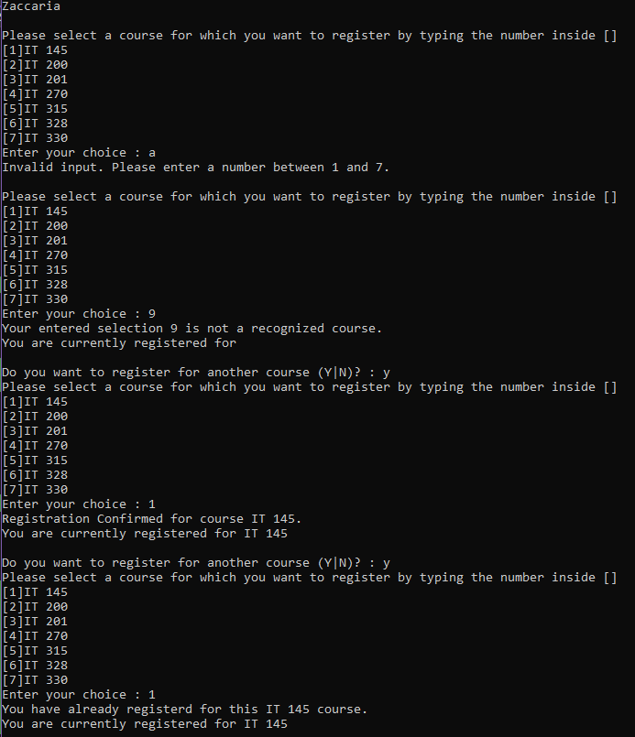

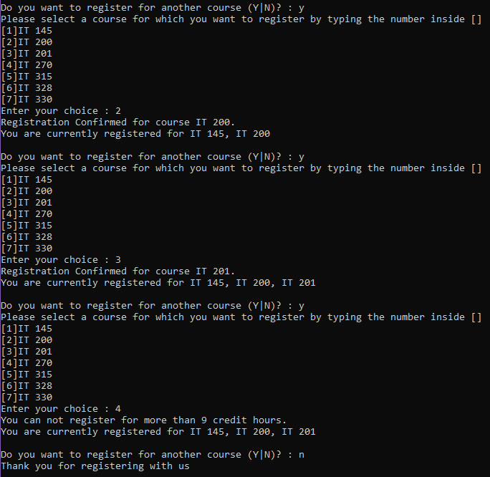

1. Copy and paste the source code text you wrote for this assignment from the *.cs file into the space below. Only providing the *.cs files or a screenshot does not meet the requirements for this part of the assignment. Code should be logically organized. It should also follow proper syntax and conventions noted in the Coding Activity Guidelines and Rubric.

using System;

using System.Collections.Generic;

using System.Linq;

using System.Text;

using System.Threading.Tasks;

namespace ConsoleRegisterStudent

{

class Program

{

static void Main(string[] args)

{

(new Program()).run();

}

void run()

{

string choice; //changed type to string

int intchoice = 0; //added variable for int version of choice

int firstChoice = 0; //moved to seperate line

int secondChoice = 0; //moved to seperate line

int thirdChoice = 0; //moved to seperate line

int totalCredit = 0;

string yesOrNo = "";

System.Console.WriteLine("Zaccaria\n"); //changed teacher's copy to my name

do

{

WritePrompt();

choice = Console.ReadLine(); //changed to just read input as string

//tries to convert string to int, if it fails, it will ask for input again

while (!int.TryParse(choice, out intchoice))

{

Console.WriteLine("Invalid input. Please enter a number between 1 and 7.\n");

WritePrompt();

choice = Console.ReadLine();

}

switch (ValidateChoice(intchoice, firstChoice, secondChoice, thirdChoice, totalCredit)) //changed choice to intchoice

{

case -1:

Console.WriteLine("Your entered selection {0} is not a recognized course.", intchoice); //changed choice to intchoice

break;

case -2:

Console.WriteLine("You have already registerd for this {0} course.", ChoiceToCourse(intchoice)); //changed choice to intchoice

break;

case -3:

Console.WriteLine("You can not register for more than 9 credit hours.");

break;

case -4: //changed case from 0 to -4

Console.WriteLine("Registration Confirmed for course {0}.", ChoiceToCourse(intchoice)); //changed choice to intchoice

totalCredit += 3;

if (firstChoice == 0)

firstChoice = intchoice; //changed choice to intchoice

else if (secondChoice == 0)

secondChoice = intchoice; //changed choice to intchoice

else if (thirdChoice == 0)

thirdChoice = intchoice; //changed choice to intchoice

break;

}

WriteCurrentRegistration(firstChoice, secondChoice, thirdChoice);

Console.Write("\nDo you want to register for another course (Y|N)? : ");

yesOrNo = (Console.ReadLine()).ToUpper();

} while (yesOrNo == "Y");

Console.WriteLine("Thank you for registering with us");

}

void WritePrompt()

{

Console.WriteLine("Please select a course for which you want to register by typing the number inside []");

Console.WriteLine("[1]IT 145\n[2]IT 200\n[3]IT 201\n[4]IT 270\n[5]IT 315\n[6]IT 328\n[7]IT 330");

Console.Write("Enter your choice : ");

}

int ValidateChoice(int intchoice, int firstChoice, int secondChoice, int thirdChoice, int totalCredit) //changed choice to intchoice

{

if (intchoice < 1 || intchoice > 7) //changed 70 to 7 and changed choice to intchoice

return -1;

else if (intchoice == firstChoice || intchoice == secondChoice || intchoice == thirdChoice) //changed and to or and changed choice to intchoice

return -2;

else if (totalCredit + 3 > 9) //checks if adding 3 credit hours will exceed 9

return -3;

else

return -4;

}

void WriteCurrentRegistration(int firstChoice, int secondChoice, int thirdChoice)

{

if (secondChoice == 0)

Console.WriteLine("You are currently registered for {0}", ChoiceToCourse(firstChoice));

else if (thirdChoice == 0)

Console.WriteLine("You are currently registered for {0}, {1}", ChoiceToCourse(firstChoice), ChoiceToCourse(secondChoice));

else

Console.WriteLine("You are currently registered for {0}, {1}, {2}", ChoiceToCourse(firstChoice), ChoiceToCourse(secondChoice), ChoiceToCourse(thirdChoice));

}

string ChoiceToCourse(int intchoice) //changed choice to intchoice

{

string course = "";

switch (intchoice) //changed choice to intchoice

{

case 1:

course = "IT 145";

break;

case 2:

course = "IT 200";

break;

case 3:

course = "IT 201";

break;

case 4:

course = "IT 270";

break;

case 5:

course = "IT 315";

break;

case 6:

course = "IT 328";

break;

case 7:

course = "IT 330";

break;

default:

break;

}

return course;

}

}

}

1. Show that you understand the task by explaining the design of your program in the space below. Include the process and steps you took to write your code. Explain how you arrived at the solution to the problem and completed the activity.

When I started working on this assignment, I again read through the program to get a feel for what it was trying to accomplish. Then I started by fixing syntax errors and formatting preferences like having each int choice be declared on its own line, changing the teacher’s copy to my name, fixing case 0 to be case –4 since that was the correct number for a return statement further down in the program, changing 70 to 7 in ValidateChoice so that if the user did not enter a number between 1 and 7, it would return –1, and changing and (&&) to or (||) in ValidateChoice so that it would return –2 if their current choice was the same as their first, second, or third choice instead of returning –2 if their current choice was the same as their first, second, and third choice. This is important to make sure that the user can never select the same course more than once. Next, I knew I needed to fix the Convert since it was not working properly and advancing throughout the program. Here I decided to use int.TryParse instead of Convert.ToInt32 because I prefer the functionality of it much more. I created a new variable named intchoice and grouped it with the other variables at the start of the program, and then I tried to convert their string input to an int; if it fails (cannot do the conversion), it outputs an error message. I used a while statement around the whole thing so that it runs until the user enters an integer. If the user enters anything besides an integer, it will give them the error message and prompt them to put in a new input. Since I had this new int variable intchoice, I needed to now go through and fix all the things that were once choice and change them to intchoice. Lastly, I needed to refine the conditions required to return –3. To refine and get it to work properly, I changed the conditions to be that if adding 3 to totalCredit makes it greater than 9, then return –3. This was enough to make the program function exactly how it is intended to.

1. Reflect on your learning experience and what you learned from completing the activity.

This assignment has been a good learning experience for me and a good test of skills and knowledge. I will admit I did need some help here and there, mainly because I was trying to overcomplicate what needed to happen to make sure that –3 was actually returned. I was going all over the place adding in if statements that ended up overriding the –3 return, and it was messing the whole program up. I had the help of a friend that is a programmer, and he basically said, Why are you making this so complicated? Just add a condition that checks if adding 3 makes it greater than 9. Something so simple, yet so overlooked by me. This was a good lesson, and one that I find myself relearning a lot, to just try and keep it as simple as possible. Just because programming is difficult does not mean I have to make my code that way too. Most of the other stuff was a good learning opportunity to get even better at things like using the int.TryParse function as well as examining program logic.